**2: Install AWS CLI**

--- Refrence links

<https://docs.aws.amazon.com/cli/latest/userguide/cli-chap-install.html>

<https://docs.aws.amazon.com/cli/latest/userguide/install-cliv2.html>

**Install aws cli on mac**

--- **note** - Download the binary and install via command line using below two commands.

**# Download Binary**

--- **curl "https://awscli.amazonaws.com/AWSCLIV2.pkg" -o "AWSCLIV2.pkg"**

**# Install the binary**

--- **sudo installer -pkg ./AWSCLIV2.pkg -target /**

**Verify the installation**

--- **aws --version**

aws-cli/2.0.7 Python/3.7.4 Darwin/19.4.0 botocore/2.0.0dev11

--- **Reference:** <https://docs.aws.amazon.com/cli/latest/userguide/install-cliv2-mac.html>

**Install and configure AWS CLI on windows**

--- The AWS CLI version 2 is supported on Windows XP or later.

--- The AWS CLI version 2 supports only 64-bit versions of Windows.

--- Download Binary: https://awscli.amazonaws.com/AWSCLIV2.msi

--- Install the downloaded binary (standard windows install)

--- **aws --version**

aws-cli/2.0.8 Python/3.7.5 Windows/10 botocore/2.0.0dev12

--- **Reference:** https://docs.aws.amazon.com/cli/latest/userguide/install-cliv2-windows.html

**Configure AWS Command Line using Security Credentials**

--- **Go to AWS Management Console --> Services --> IAM**

Select the IAM User: kalyan

--- **Important Note:** Use only IAM user to generate Security Credentials. Never ever use Root User. (Highly not recommended)

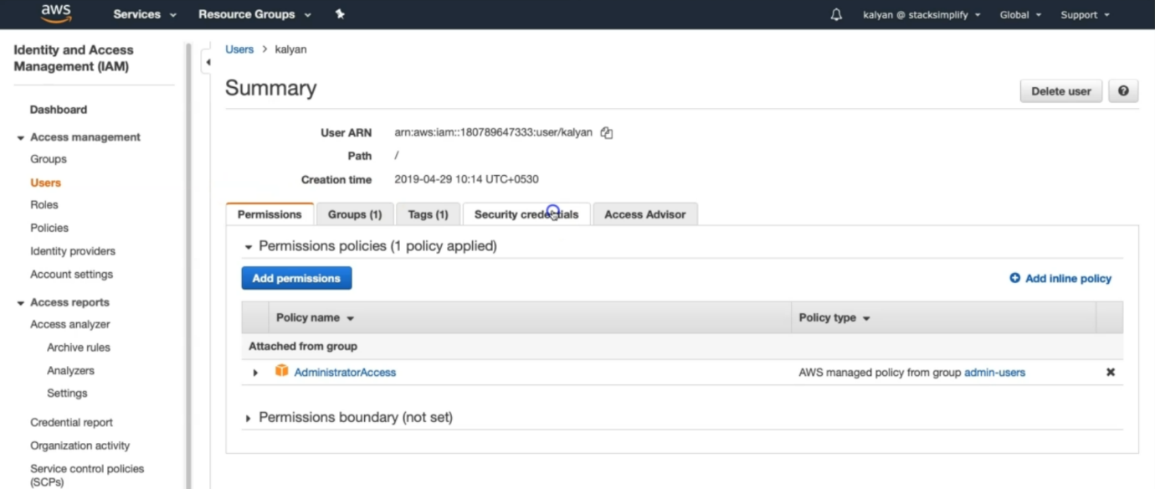

--- Click on Security credentials tab

--- Click on Create access key

--- Copy Access ID and Secret access key

--- Go to command line and provide the required details

--- **aws configure**

AWS Access Key ID [None]: ABCDEFGHIAZBERTUCNGG (Replace your creds when prompted)

AWS Secret Access Key [None]: uMe7fumK1IdDB094q2sGFhM5Bqt3HQRw3IHZzBDTm (Replace your creds when prompted)

Default region name [None]: us-east-1

Default output format [None]: json

--- **note** - Test if AWS CLI is working after configuring the above

--- **aws ec2 describe-vpcs**